Rae Colborne, Linda Fahlgren-Moe, Kailey Mutter & Martin Rothwell
With Rachael Contorer, Dave Hoskin, Gregg Robinson & Doug Ostgard

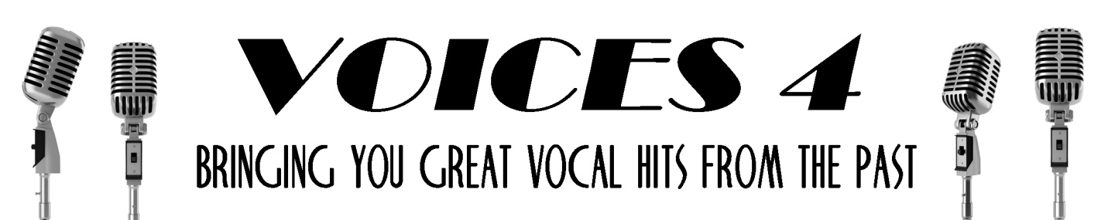

Come and join us for fun and music at
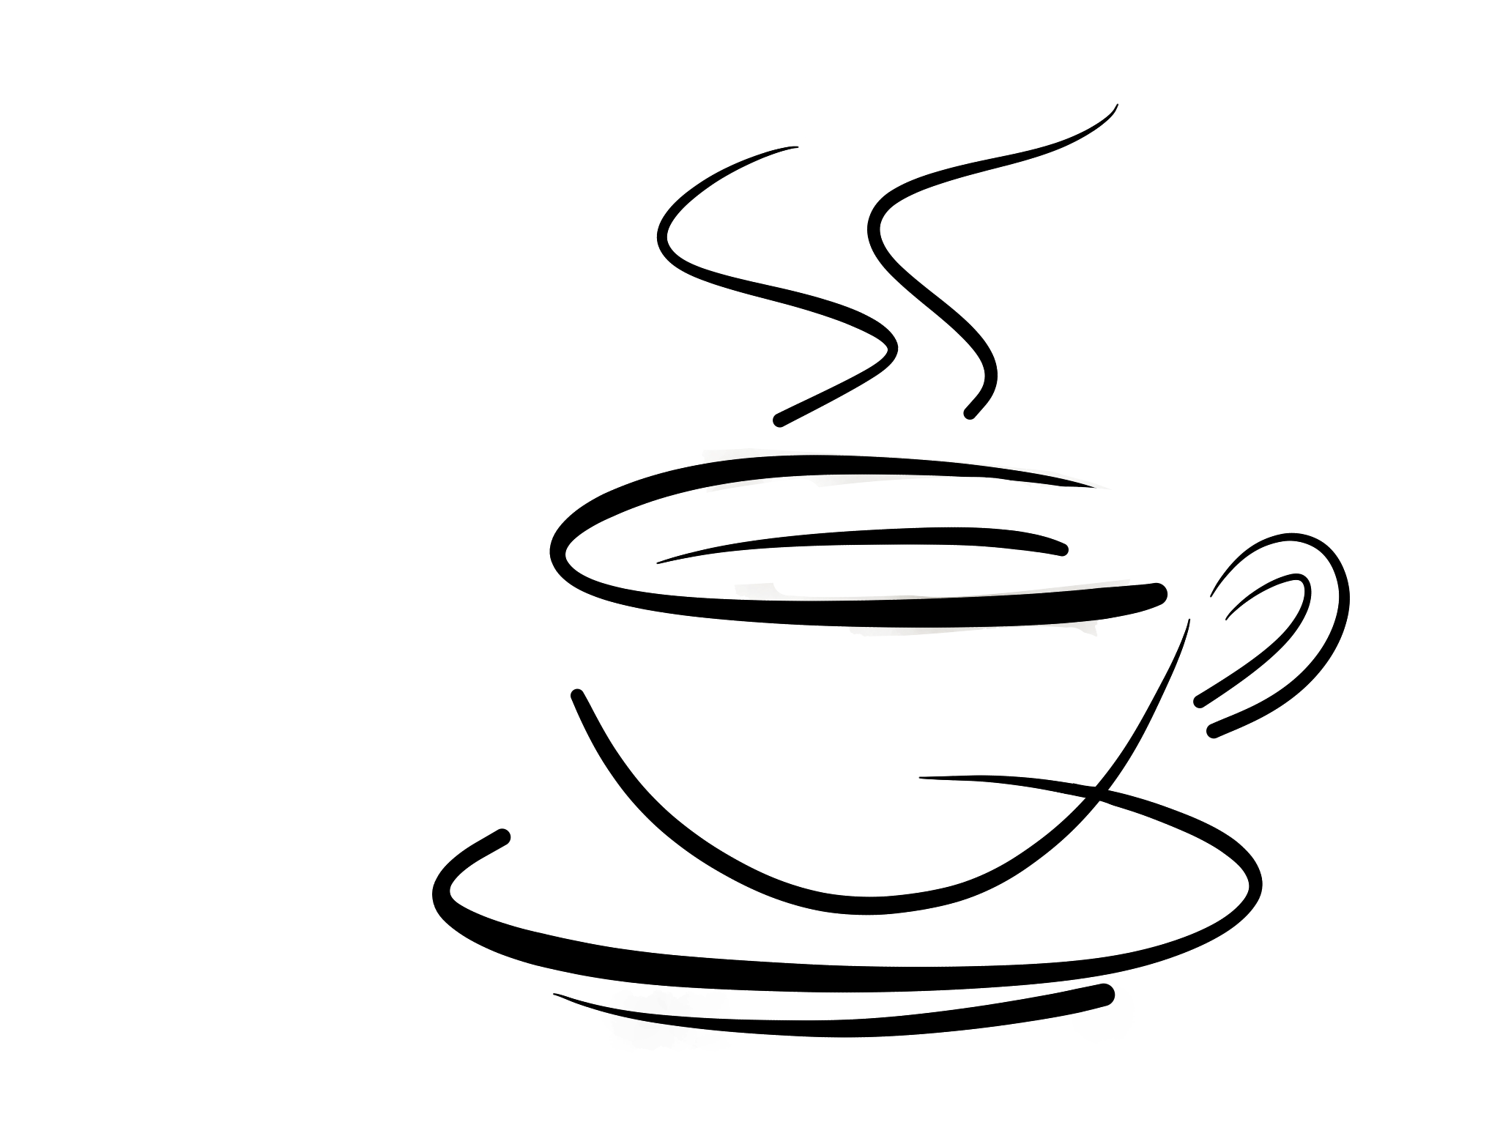
Zola’s Cafe!
Friday, June 1st from 7 – 9 p.m.
402 E Main Street in Auburn

